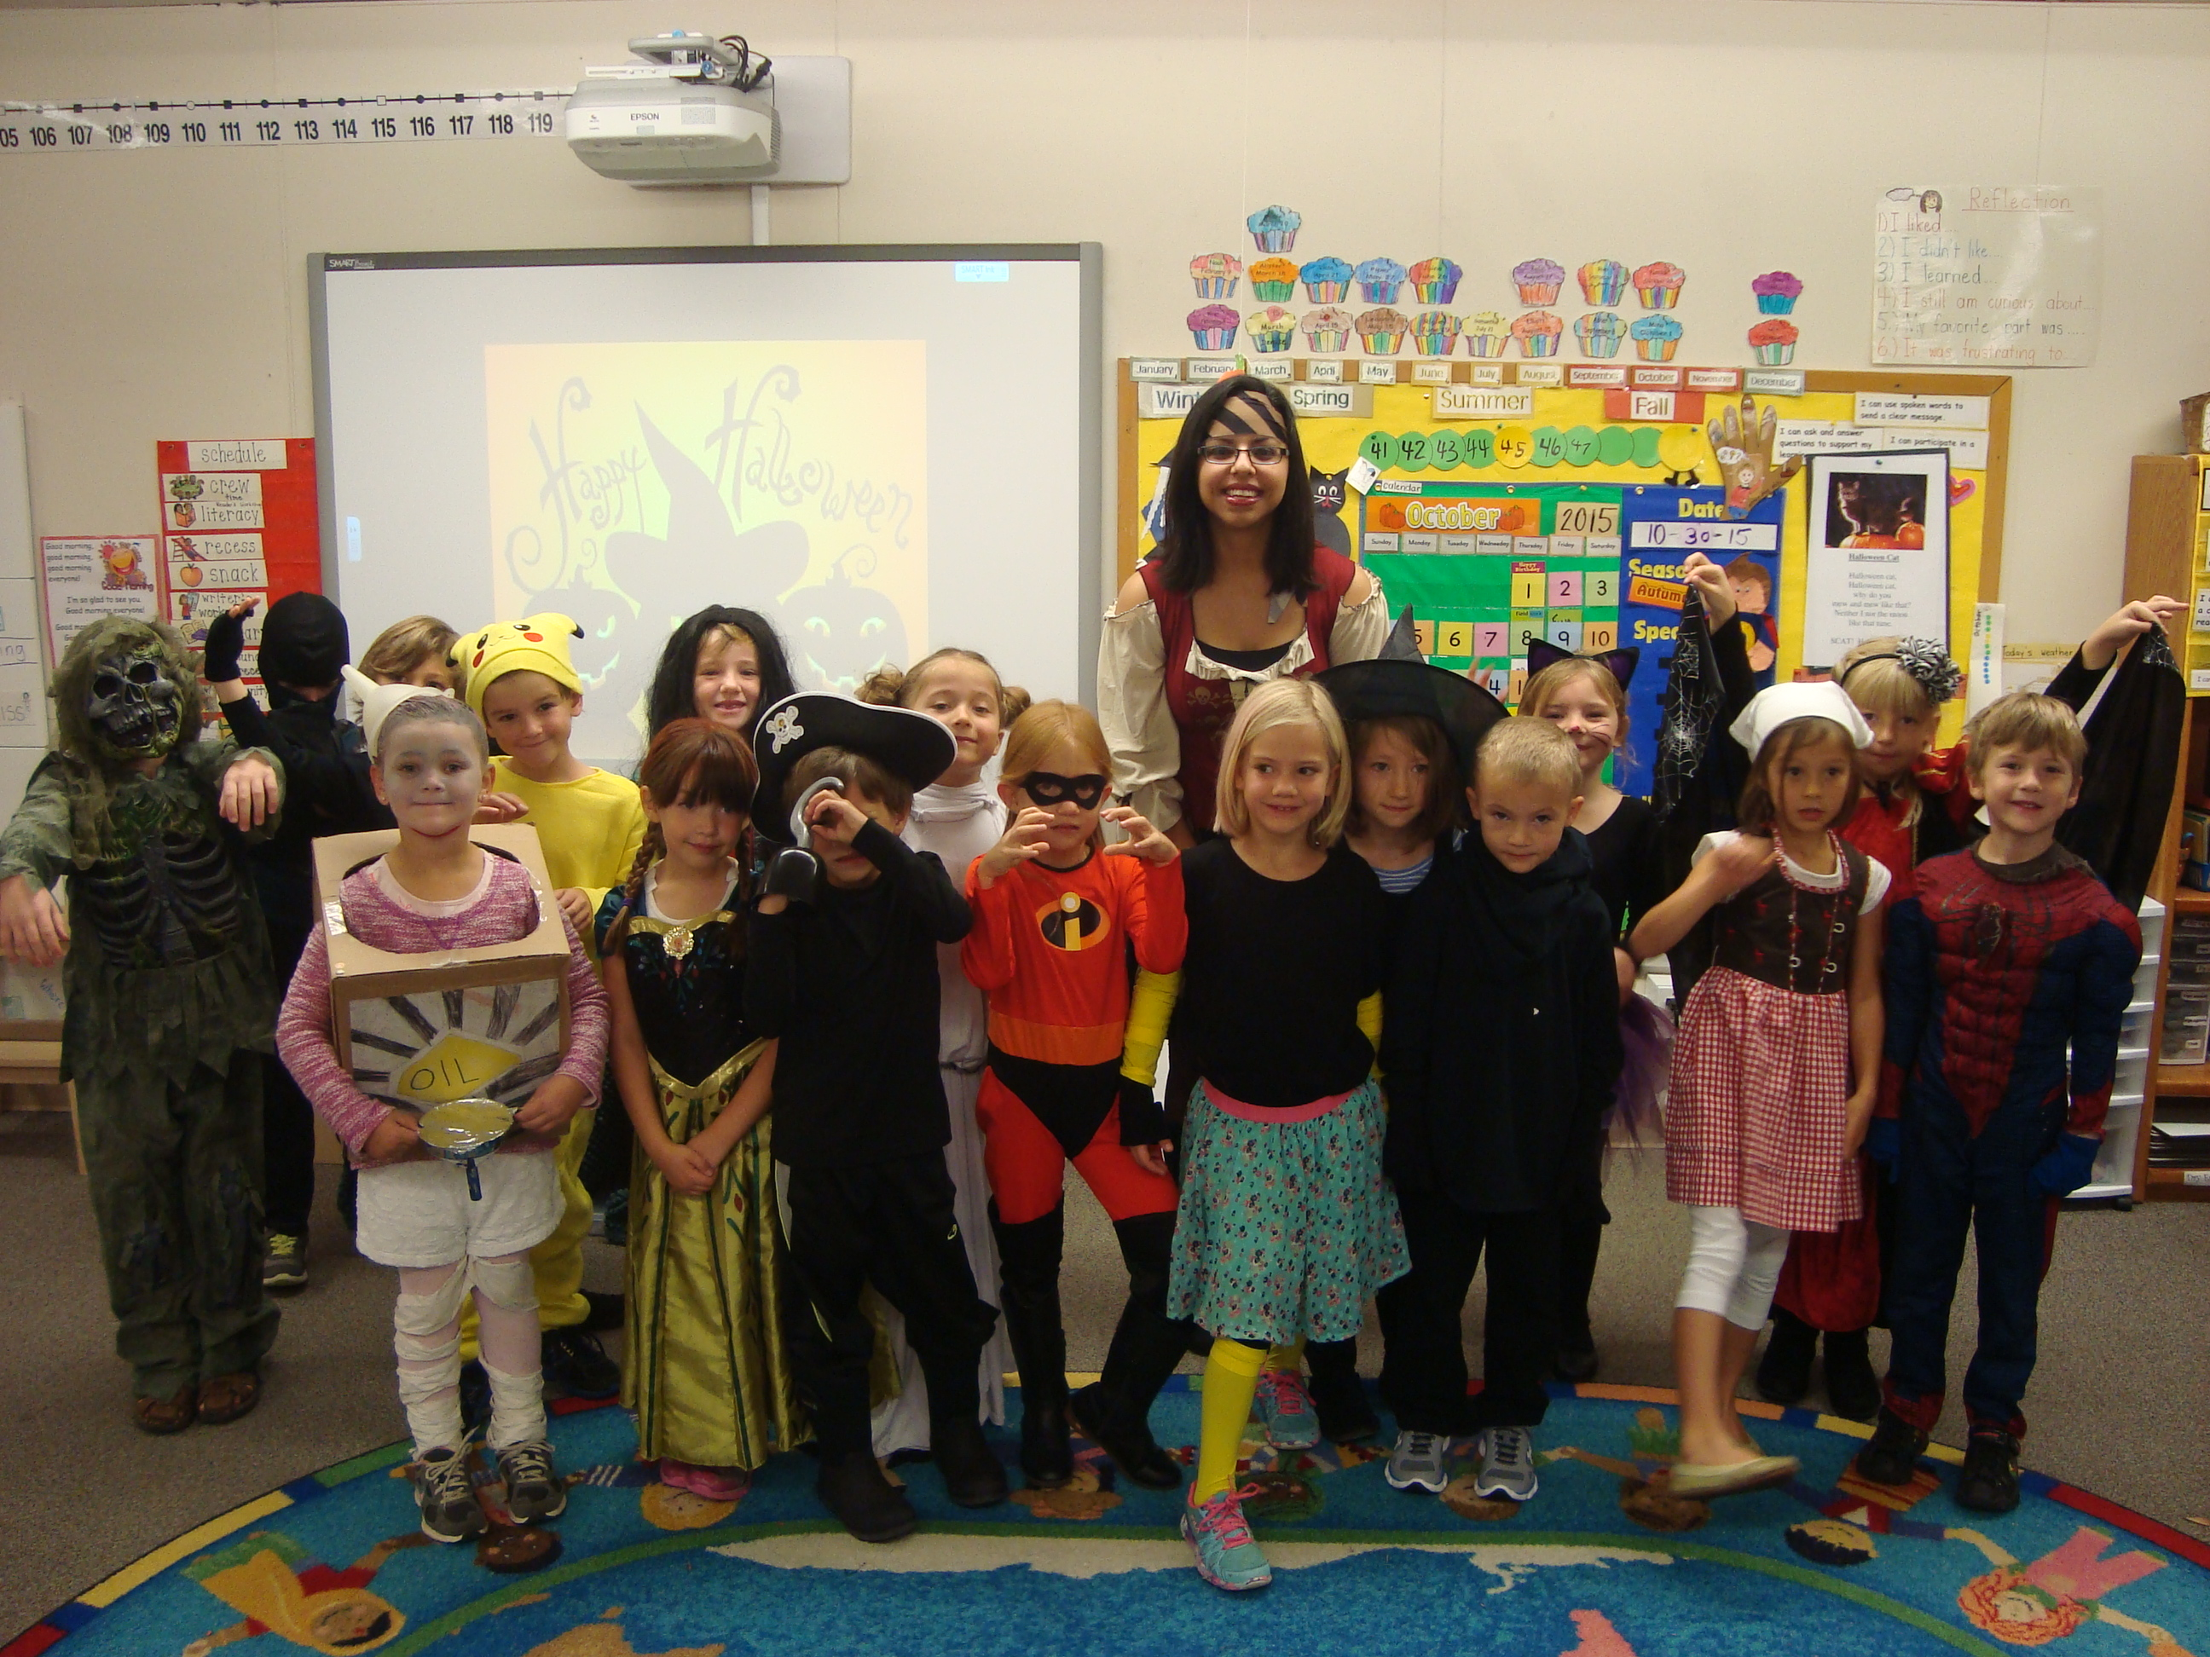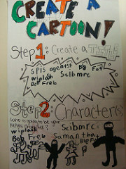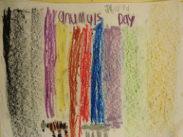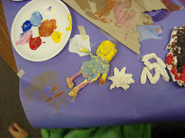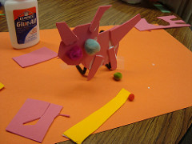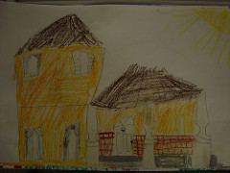

1. Observe and Learn to **Comprehend:**

-Artists pick materials & technique to show how they use color, line shapes in their art to express meaning

-Works of Art express feelings

-Art represents and renders the stories of people, places, or things

2.Envision and Critique to **Reflect:**

-Artists get better in their art making by practicing, brainstorming, and reworking on their art.

-Visual arts provide opportunities to respond to personal works of art and the art of others

3. Invent and Discover to **Create:**

-Artists use materials to make different kinds of arts.

- Create art to communicate ideas, feelings, or emotions

4. Relate and Connect to **Transfer:**

-Works of art reflect the experiences of the artist.

-Creative and deep thinking are important life skills that can grow.

- Visual arts relate experiences to self, family, and friends

### Standards and Grade Level Expectations explored:

The exhibition will be in the **multipurpose room** featuring students’ artwork K-5! Come and see what they’ve been working on this whole semester of Fall 2015.

Thursday December 10th – Friday December 11th

##### LAB SCHOOL ART EXHIBITION!

# SUMMARY OF THE UNIT:

# CULTURE

With Tod Aldrich and Rosalba Soto

Denise’s 1st Grade Class

ART CLASS FALL 2015

DURING THE UNIT STUDENTS HAD THE OPPORTUNITY TO EXPLORE CULTURE AROUND THE WORLD AND THINK ABOUT THEIR OWN. WE DID THIS THROUGH HOMES, ARTIFACTS, MONUMENTS AND CELEBRATIONS.

#### Save the Date!

To see more of the student’s in-progress artworks, please visit our website!!

www.kand1culture.weebly.com

http://kand1culture.weebly.com[**http://kand1culture.weebly.com**](http://kand1culture.weebly.com/)

[**http://kand1culture.weebly.com**](http://kand1culture.weebly.com/)

This lesson plan we talked about invention and how art can be the result of happy accidents. Students created a cartoon TV show for the company Nickelodeon, they had to create a title, character(s), and the world they lived in. After doing that, students had the option of recreating their character(s) in either 2-D or 3-D.

## Lesson 5: Pop Culture

All cultures have celebrations and so students had the opportunity to create their own celebration and an object from it.  They filled out little booklets so they could record their celebration then they had to make an object or artifact from that celebration.  They used found objects likes pipe-cleaners, feathers, foam paper, and buttons. Then students created collages based upon their celebrations using paper and foam paper.

## Lesson 4: Celebrations

All cultures have artifacts for all aspects of life, even today artifacts are being left behind for generations to come.  It was started with a dig in the school playground with objects from their classroom buried beneath the mulch.  After that students had to draw out their artifacts in order to get clay to make their objects.  Once fired the clay pieces were painted to help make them unique and special.

## Lesson 3: Cultural Artifacts

Many cultures have monuments and shrines so students were to use foam paper to create a monument for someone or something special to them.  They also had access to found object like buttons, feathers, and pipe-cleaners to use in their monuments.  Students were challenged to consider how their construct relates to the object in question of the worship, like color, shape, or size.

Here the plan was to have students recreate their home, from memory and consider what makes home special. Students then had water colored pencils and pastels introduced for use in their art to recreate their homes. Making the homes are about students thinking in relation to themselves with how their culture depicts their ways of life.

## Lesson 2: Cultural Monuments

## Lesson 1: Your Home