Lesson Plan Title: Cultural Artifacts Length: 8:30-9:30a

Note: Before you plan and write art experiences; pre-assess your students based on the proposed concepts, enduring understandings, and objectives of the unit/lesson(s). You may also gather this information from (previous) teachers, by reviewing already completed art work, consulting curriculum materials, etc., to get a better understanding of what content students already know and what they will need to know to be successful.

Pre-Assessment:
This will need to be done prior to teaching your lesson. Outline the method you will use to determine the skill/knowledge level of your students based on the concepts/enduring understandings/objectives of the lesson. (Hint: turn these into questions.) Be specific in describing what you would recognize as proficient skill/knowledge.
Given new materials, will students create a cultural artifact based on who they are?
Based on PowerPoint, will students explain what an artifact is?
Using brainstorming, will students develop plans to make their artifact unique?
Given their artwork, will students verbalize the intent/purpose of their artifact to their peers in a critique?

Performance:
What will students accomplish as a result of this lesson? This can be presented to students in the form of a story. In this narrative the students take on a role and create a learning product about a specific topic for a certain audience. (RAFT – Role / Audience / Format / Topic)
The alien Tosalba is wondering why people on earth have so many things that are unique to them. “Artifacts” is what these humans call them, by definition they are “an object made by a human being, typically an item of cultural or historical interest.” They show cultures past and beliefs and who they were as people. As an artist what would your personal artifact be to show Tosalba who you are as a person and as a culture?

Tosalba is back and is curious about the artifact you created. She is wondering about your little trinkets known as artifacts and is curious on how you use color to create meaning. So through color you will describe how the little artifact you made represents you. If your artifact is in many pieces how will you fix it? Or even how could it be changed? Help Tosabla understand how we use color to express yourself with the artifact you made.

Concepts:
List the big ideas students will be introduced to in the lesson. These ideas are universal, timeless and transferrable. Examples of concepts used in art might include: Composition, Patterns, Technique, Rhythm, Paradox, Influence, Style, Force, Culture, Space/Time/Energy, Line, Law/Rules, Value, Expressions, Emotions, Tradition, Symbol, Movement, Shape, Improvisation, and Observation Look for concepts in the standards, content specific curriculum, etc.
- Artists planning
- Ideas (Ideation)
- Culture
- Shape
- Color Mixing

Enduring Understanding (s):
Enduring Understandings show a relationship between two or more concepts; connected with an active verb. The best enduring understandings not only link two or more concepts; but demonstrate why this relationship is important. Like concepts, they are timeless, transferrable and universal. Align Standards, Prepared Graduate Competencies (PGCs) and Grade Level Expectations (GLEs) to Enduring Understandings.
Through the creative process, artists have a better understanding of their cultures.
Planning and generating ideas is an important part of the art making process.
Interpretation of world through own art.

Standards: (All lessons should address all standards.)
1. Observe and Learn to Comprehend
2. Envision and Critique to Reflect
3. Invent and Discover to Create
4. Relate and Connect to Transfer

Objectives/Outcomes/Learning Targets:
Objectives describe a learning experience with a condition → behavior (measurable) → criterion. Aligned to: Bloom’s – Standards – GLEs - Art learning and, when appropriate, Numeracy, Literacy and Technology. Should be written as: Objective. (Bloom’s: _____ - Standard: _____ - GLE: _____ -Art learning: _____ -Numeracy, Literacy, and/or Technology)
Given new materials, SWBAT create a cultural artifact based on who they are. (Creating; Reflect/Create: achieve artistic purpose to communicate intent; Inherent Characteristics and expressive features)
Based on PowerPoint, SWBAT explain what an artifact is. (Understanding; Comprehend; Understanding works of art involved knowledge of historical and cultural styles, genre, and artists over time; Art History/Culture)
Using brainstorming, SWBAT develop plans to make their artifact unique. (Creating; Reflect/ Create; Achieve the ability to plan, anticipate outcomes, and demonstrate craftsmanship in creating a work of art; Ideation)
Given their artwork, SWBAT verbalize the intent/purpose of their artifact to their peers in a critique. (Applying: Transfer/Create; Use of different materials and media to express meaning in works of art; Reflection)

Differentiation:
Explain specifically how you have addressed the needs of exceptional students at both end of the skill and cognitive scale. Describe the strategies you will use for students who are already proficient and need growth beyond what you have planned for the rest of the class, as well as modifications for students with physical and/or cognitive challenges. Students must still meet the objectives.

Differentiation:  (Multiple means for students to access content and multiple modes for student to express understanding.) | Access (Resources and/or Process) | Expression (Products and/or Performance)
 | 1. If students are done early, there will be an idea bucket with a variety of “prompts”. | 1. Students will then sketch based on what the prompt says, thus giving them another option to do while their classmates finish their projects.
Extensions for depth and complexity: | Access (Resources and/or Process) | Expression (Products and/or Performance)
Extensions for depth and complexity: | 2. When given options students are more likely to not get off task. | 2. Allows the student to be engaged and draw out more ideas.

Literacy:
List terms (vocabulary) specific to the topic that students will be introduced to in the lesson and describe how literacy is integrated into the lesson.
Vocabulary: artifacts, culture, two or three dimensional artwork

literacy integration:
students will explain their intent of work by describing what they created.

Materials:
Must be grade level appropriate. List everything you will need for this lesson, including art supplies and tools. (These are the materials students will use.) List all materials in a bulleted format.
Sketchbooks
Clay
Newspapers/ paper to protect the tables

Day 2:
- Brushes
- Paints (acrylic/tempera)
- Bowls for water
- Hot-glue guns (Preferably low temp kind)
- Hot-glue sticks
- Sketchbooks

Resources:

List all visual aids and reference material (books, slides, posters, etc. Be specific; include title, artist, etc. Make reference to where the material can be found. (These are the resources used by the teacher to support/develop the lesson.) List all resources in a bulleted format.
Powerpoint
Our own personal artifact

Images:
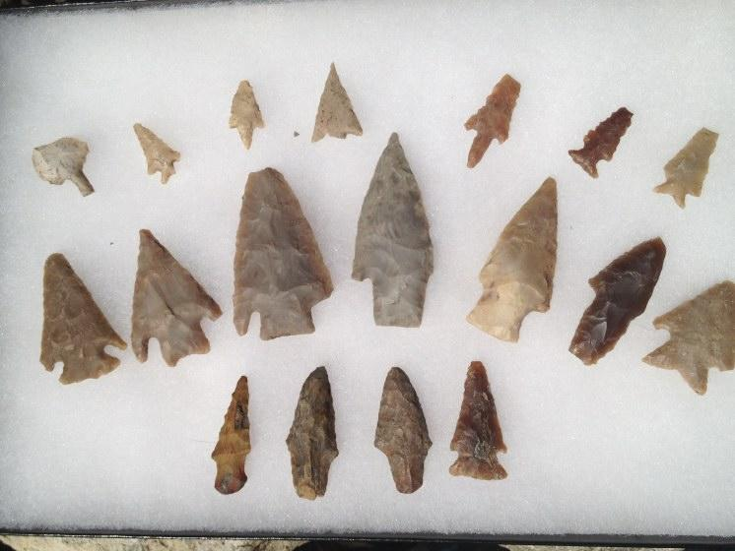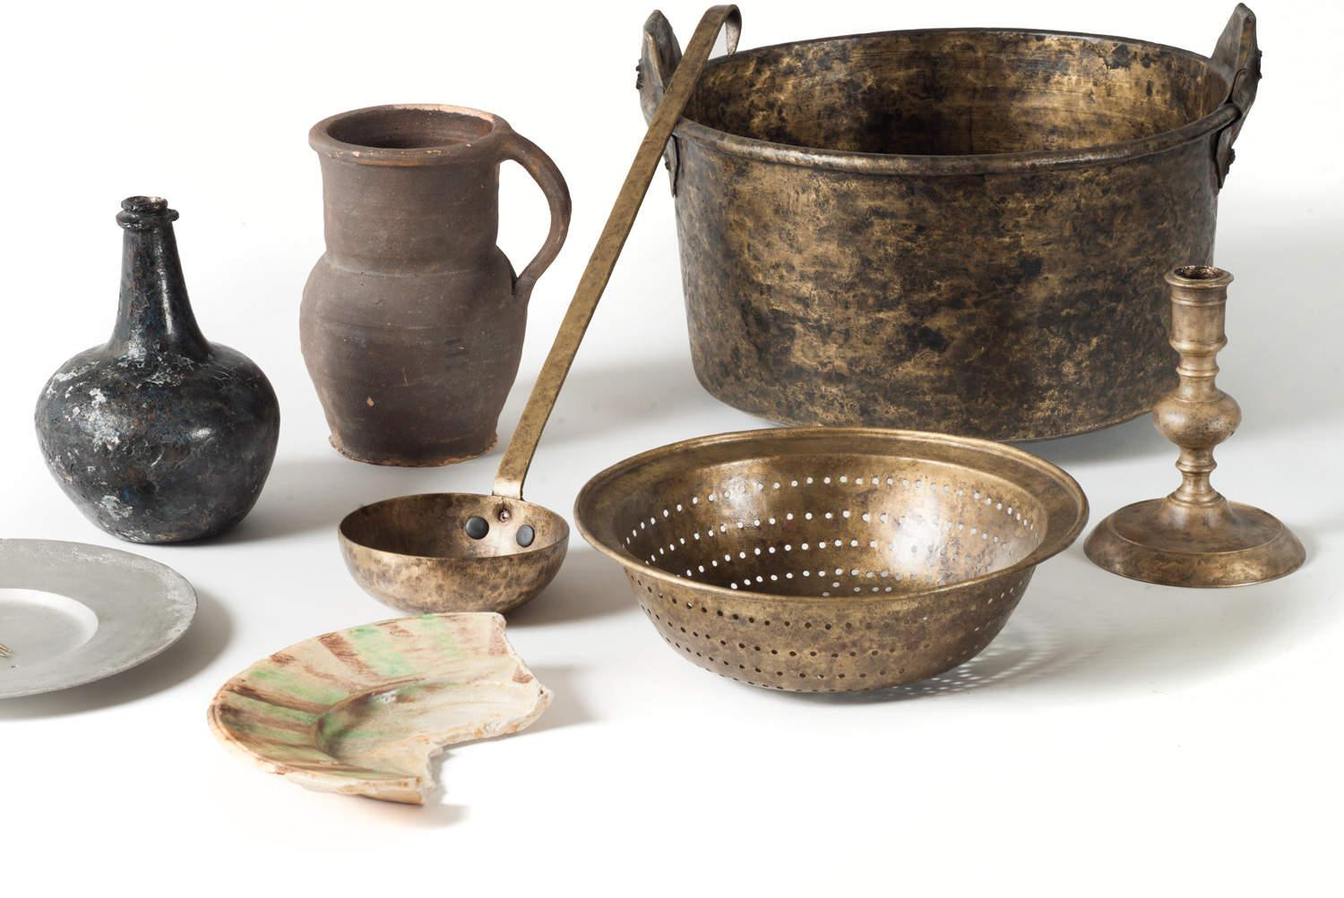
Day 2:
- PowerPoint about color
  - Have an image of the color wheel and talk about the primary colors: blue, red, and yellow.
  - Talk about mixing colors like blue and yellow make green, red and blue make purple.
  - And mention how mixing all colors will create a brown.
  - To prepare students for mixing with paint.
- Their sketchbooks for when they finish early and go to the idea bucket.
- The students clay artifacts that have been fired.

Images:
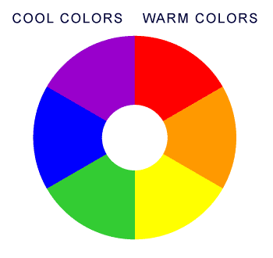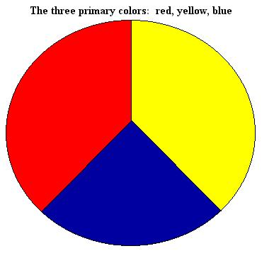

Preparation:
What do you need to prepare for this experience? List steps of preparation in a bulleted format.
Have tables set up with the appropriate materials.

Safety:

Be specific about the safety procedures that need to be addressed with students. List all safety issue in a bulleted format.
Students are required to sit in their appropriate seats
No running
No throwing art materials to one another

Action to motivate/Inquiry Questions:
Describe how you will begin the lesson to stimulate student’s interest. How will you pique their curiosity and make them interested and excited about the lesson? What inquiry questions will you pose? Be specific about what you will say and do to motivate students and get them thinking and ready to participate. Be aware of the varying range of learning styles/intelligences of your students. Some ideas might include: telling a story, posing a series of questions, role-playing, etc.
RAFT
Own personal artifact
Short clip on historical artifacts

Ideation/Inquiry:
Ideation is the creative process of generating, developing, and communicating new ideas, where an idea is understood as a basic element of thought that can be visual, concrete or abstract. List and describe inquiry questions and processes you will engage students in to help them develop ideas and plans for their artwork.
Based on powerpoint slides, what makes an artifact personal?
Visualizing your bedroom, what object or thing can be a personal artifact to you?
What is something that describes who you are? A toy, musical instrument, video game?

Instruction:
Give a detailed account (in bulleted form) of what you will teach. Be sure to include approximate time for each activity and instructional methodology: skills, lecture, inquiry, etc. Include motivation and ideation/inquiry where appropriate; including what student will understand as a result of the art experience

Day 1 | Instruction - The teacher will... (Be specific about what concepts, information, understandings, etc. will be taught.) Identify instructional methodology. KNOW (Content) and DO (Skill)  - Teacher will start out by showing powerpoint slides of different artifacts from around the world  - (Slides to be determined)  - And a short clip of an excavation or historical artifacts found (TBD)  - Teachers will then present their own artifacts to students and explain why they chose it/ what it means to them.  - Students will then go to their seats and start ideating on their sketchbooks what their personal artifacts could be.  - Time to think and not get stuck on playing with their materials.  - Whenever someone is done sketching in their sketchbooks they’ll be allowed to come up to us and show us what they want to build and get clay form us.  - Students will get a block of clay to start off with in their process of creating their artifact.  - Allow time for clean up at the end. | Learning - Students will... i.e.: explore ideation by making connections,  comparing, contrasting; synthesize possibilities for each painting technique; etc. (Be specific about what will be the intended result of the instruction as it relates to learning.) UNDERSTAND  - Identify what artifacts are.  - Students comprehend the role of documenting their art idea making through their sketchbook.  - Students will understand their own creative process by using art materials to create their end product.  - Students will practice ideation through storytelling. | Time  5-7 mins  6-10 mins  10-15 mins  20 mins  10 mins
Day 2 | - A quick review of artifacts and see if they remember what we showed them and what they made.  - Then have the short presentation on color to prepare students for using and mixing color paints. At the end have a ‘demo’ of mixing colors.  - The first slide will be of the color wheel  - Then we will talk about the three primary colors while they are up on the board.  - Quiz students to see if they already know  - Then have examples of mixing, the following slides will be like (color)+(color)=(color)  - like Blue and Red make Purple  - Yellow and Red make Orange  - Blue and Yellow make Green  - mixing of all make Brown  - After the mixing example ask about how they could make other colors. Have the students mix colors, pick four students to attempt mixing of paint that is displayed upon a plate..  - After slide show, it will be time to allow students to start painting.  - We will also have a glue station set up so students who have broken artifacts will be able to fix them.  - And will have all other tables be prepped for painting.  - Then group up the students to talk about their newly painted/colored artifacts.  - We will talk about what colors they used how they used them and have these questions in mind  - Why did you choose this color(s)?  - How is it special to you?  - Is it your favorite color?  - How will you create this color? What colors will you be mixing?  - What colors is the artifact based on? What was the source of your artifact’s color?  - Clean up supplies | - Review  - Learning about expression through color and mixing of color.  - Painting a Third Dimensional creation.  - Group Discussion  - Accountability for mess | - 5 min  - 5-6 min  - 20-30 min  - 5min  - 10 min

Student reflective/inquiry activity:
Sample questions and activities (i.e. games, gallery walk, artist statement, interview) intended to promote deeper thinking, reflection and refined understandings precisely related to the grade level expectations. How will students reflect on their learning? A participatory activity that includes students in finding meaning, inquiring about materials and techniques and reflecting about their experience as it relates to objectives, standards and grade level expectations of the lesson.)
Having students talk about their work with their neighbor.
Have them talk about why they made their artifact and what it means to them.
Storytelling

Post-Assessment (teacher-centered/objectives as questions):  Have students achieved the objectives and grade level expectations specified in your lesson plan? | Post-Assessment Instrument:  How well have students achieved the objectives and grade level expectations specified in your lesson plan? Include your rubric, checklist, rating scale, etc.
Given new materials, did students create a cultural artifact based on who they are?  Based on PowerPoint, were students able to explain what an artifact is?  Using brainstorming, did students develop plans to make their artifact unique?  Given their artwork, are students able to verbalize the intent/purpose of their artifact to their peers in a critique? | Student Name_______________________________________  Create a cultural artifact based on who they are. ___________  Explain what an artifact is. __________  Develop plans to make their artifact unique. _________  Verbalize the intent/purpose of their artifact to their peers in a critique. ____________  Super- Work is finished with a lot of detail and is about me.  Well done- Work is finished with detail and is about me.  Okay- Work is almost finished with some detail and little personal meaning.  Getting there- Work is not finished and has no personal meaning.

Self-Reflection:
After the lesson is concluded write a brief reflection of what went well, what surprised you, and what you would do differently. Specifically address: (1) To what extent were lesson objectives achieved? (Utilize assessment data to justify your level of achievement.) (2) What changes, omissions, or additions to the lesson would you make if you were to teach again? (3)What do you envision for the next lesson? (Continued practice, reteach content, etc.)
TA  Class #4  10/2/15  What worked well for this art experience? Why?  I loved the archaeological dig idea that I think went very well they really seemed to enjoy looking for ‘lost things’. I think it also helped them think about artifacts a little more even if we never defined it I think they will see artifacts differently. I also tried to speak up more which I know is my issue and they acknowledged me as well. I used the idea our proctor said about having the students talk amongst themselves about artifacts  What would you do differently? Why?  Differently what would I do, well I am not sure I liked how the whole lesson went all together. Clean-up didn’t seem to be as bad and the students’ attending skills are getting better. Maybe more clay for those who want it we only could have so much and I didn’t expect how many would just build with it. I never had a lesson with clay yet but I figured that this age group would just want to build everything with no end in sight.  Class #7  10/30/15  What worked well for this art experience?  Not much didn’t work I thought it went very well, it went along swimmingly. We had several students who were excited to paint, and I loved the energy.  What would you do differently?  What I would do differently is making sure all pieces were etched into with student initials. It never occurred to me that we would lose anyone’s stuff which I do feel bad about but they were still able to paint because we had a collection of pieces that had no names. | Rosalba Soto- Vazquez  CLASS: #4  DATE: October 2nd, 2015  Each entry should have 3 parts:  What worked well for this art experience? Why?  Showing a video for the first time to the class seemed to work well because it caught their interest. Having something besides us talking to them helped. Another great thing was the outside activity we had planned for them. Everyone was eager to find “found objects” and managed to not lose any. Making sure that we told the students the directions helped tremendously, they started of with sketching their ideas and once they were done they showed the teachers their artifact and were able to get a piece of clay and start working on their projects.  What didn’t work well for this art experience? Why?  I found that some students work really fast and others very slow. During their sketch idea time, there were a few students who took more time sketching than actually playing with the clay. In the end those students had hardly done anything with their clay. But I don’t think that was avoidable because they could have taken a long time with their clay as well.  What would you do differently? Why?  Assigning specific students to clean up. Surprisingly this time it went smoother than other times, much faster. But it can be a bit hectic while some students clean up other students are running around doing nothing. We need to come up with a better system.

Appendix: Include all handouts, prompts, written materials, rubrics, etc. that will be given to students.

8/9/15 Fahey

